**Unit 7 Contour Crafting**

1. Introduction

*1.1 Read the text title and hypothesize what the text is about. Write down your hypothesis* …………………………………………………………………………………………………….…………………………………………………………………………………………………….……………………………………………………………………………………………………

*1.2 What do you know concerning this issue? List your ideas in the table left column "I know".*

|  |  |
| --- | --- |
| I know | I have learnt |
|  |  |
|  |  |
|  |  |
|  |  |
|  |  |

1.3 *Do you know answers to these questions? Write down your short answers in the space given after each question.*

|  |  |
| --- | --- |
| 1  Are people standards of living the same in different countries?  What are some of the rules about changing business cards?  Where is it unusual to shake hands whea meeting? Why?  Do you know any rules about clothes?  Is it OK to discuss business when eating?  What does this saying mean: "When in Rome, do as the Romans do"? | Who developed Contour Crafting technology? |
|  |  |
| 2 | What is one of the main advantages of the Contour Crafting process? |
|  |  |
| 3 | What were the first applications of 3D Printing? |
|  |  |
| 4 | What is the [3D printer](http://inhabitat.com/tag/3d-printing/)? |
|  |  |
| 5 | What products are made using 3D printing? |
|  |  |
| 6 | What opportunities do 3D printing architectural models provide? |
|  |  |
| 7 | What is the difference between traditional 3D printers and Contour Crafting? |
|  |  |

1.4 *Circle in the list the words and expressions you know. Write down their translation in table and calculate the percentage of your lexical competence.*

|  |  |  |  |  |  |
| --- | --- | --- | --- | --- | --- |
| 1 | rectilinear shapes |  | 9 | redevelopment |  |
| 2 | marble powder |  | 10 | to extract data |  |
| 3 | surface finish |  | 11 | natural disaster |  |
| 4 | outer surfaces |  | 12 | manual assembly |  |
| 5 | flexible |  | 13 | detached building |  |
| 6 | versatile |  | 14 | complex geometries |  |
| 7 | site plan |  | 15 | master plan |  |
| 8 | emergency shelter |  | 16 | conduit |  |

**Contour Crafting**

Contour Crafting (CC) is a layered fabrication technology developed by Dr. Behrokh Khoshnevis, professor of the University of Southern California. His approach relies on mobile large-scale, lightweight 3D printers which can be transported to a job site quite easily. Once transported the machine is assembled and can begin constructing homes or other large structures, layer-by-layer, reducing the waste, cost, and time it takes to construct a building.

[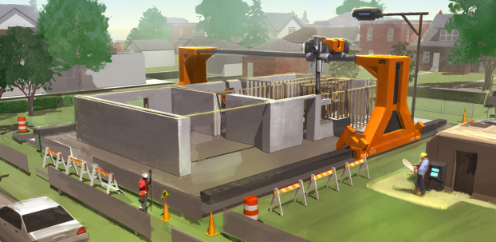](http://3dprint.com/wp-content/uploads/2015/03/28.png)Contour Crafting technology has great potential for automating the construction of whole structures as well as sub-components. Using this process, a single house or a colony of houses, each with possibly a different design, may be automatically constructed in a single run. CC is a very flexible technique, capable of constructing aesthetically pleasing “organic” curvilinear shapes as easily as “boxy” rectilinear shapes.

Contour Crafting is a major innovation that automates the construction of whole structures; and radically reduces the time and cost of construction. The result would be a revolution in the construction industry that would lead to affordable construction of high quality low-income housing; the rapid construction of emergency shelters and on-demand housing in response to disasters. Contour Crafting is the first and only large-scale 3D printing technology that can rapidly construct complete buildings.

**This new 3D-printing** system can produce entire homes equipped with basic necessities on-site in under 24 hours - a feat that hasn't been done by any other 3D-printer before.

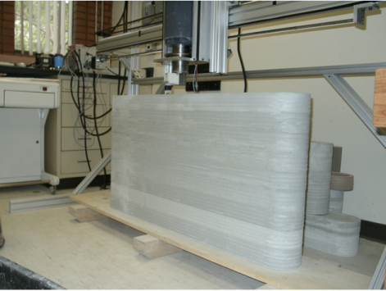Robotic construction system Contour Crafting (CC) has debuted their newest 3D-printing technology that can print entire homes on-site in less than 24 hours. CC’s technology doesn’t just build the architectural structure, it also prints the electrical, plumbing, and air conditioning features mid-construction, with no manual assembly required. Essentially, CC is printing homes in one shot with the basic utilities already embedded into their 3D-printed structures. It only takes 19 hours to print a 2,500 square foot home, at a rate of 20 seconds per square foot.

The whole process is done in only four steps: ***The machine in action***

* Flattening the required space.
* Using the excavating crane to create a foundation, which is then filled with concrete.
* The Contour Crafter is then positioned on the top of a specially-made crane that keeps it from sinking in the mud, then it moves along the X,Y (height), and Z (crossbeam) axes.
* An extremely fast drying concrete is then pumped into the front of the CC, and the pipe system starts the construction of the house.

**Behrokh Khoshnevis** is a professor of Industrial & Systems Engineering, Aerospace & Mechanical Engineering, Astronautics Engineering, Biomedical Engineering and Civil & Environmental Engineering and is the Director of the [Center for Rapid Automated Fabrication Technologies(CRAFT)](http://craft.usc.edu/).  He is active in robotics, and mechatronics related research and development projects that include the development of 3D Printing processes called Contour Crafting.Contour Crafting has been identified as one of the major headmost technologies of our time. Professor Khoshnevis was inspired to build this machine after an earthquake destroyed the city of Bam in his native Iran. Witnessing the devastation, Khoshnevis realized that a technology was needed to allow people to build stable homes in a rapid and economical manner.

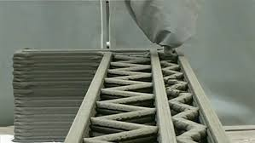In 2006, Dr. [Behrokh Khoshnevis](http://www.archdaily.com/search/?q=Behrokh%20Khoshnevis" \t "_blank) introduced the world to [Contour Crafting](http://www.archdaily.com/tag/contour-crafting/). Contour Crafting (CC) is a computerized construction method that 3D Prints large-scale structures directly from architectural CAD models. As Dr. Khoshnevis explains, Contour Crafting uses a giant 3D printer that hangs over a designated space and robotically builds up the walls of that building with layers of concrete. Walls are built up by forming their outer surfaces via extrusion of a paste-like material, such as concrete, and the use of a robotic trowel to provide a smooth contoured surface. One of the chief advantages of the Contour Crafting process over existing technologies is the superior surface finish. The robot can paint the walls and tile surfaces and even knows to embed in each house all the conduits for electrical, plumbing and air-conditioning.

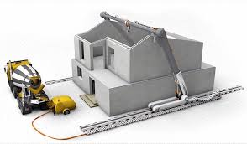The [3D printer](http://inhabitat.com/tag/3d-printing/) has two crane-like arms and a crossbeam which carries the printhead. The entire machine runs along a set of tracks and can work on all parts of the house simultaneously. Professor Khoshnevis believes the printer can build an entire two-story house in just under a day. For the printer to do its work, the space around the site needs to be prepared and the foundation in place. Additional work is required when it comes to window head jambs and metal ceiling, which can be done either by hand or by cranes. The rest of the process is almost completely automated.

By automating the construction process – one of the only processes humans still do largely by hand – homes will be cheaper and more quickly erected, with significantly lower labor costs. Besides, Contour Crafting is a construction technology that potentially reduces energy use and emissions. The innovative technology of 3D printing large structures could revolutionize the building industry and help meet the growing demand of housing in city centers. Meanwhile, [NASA](http://inhabitat.com/tag/nasa-3d-printing/) has given Khoshnevis a grant to experiment with lunar structures and buildings that could potentially be erected on other Earth-like planets.

We are now seeing some companies developing 3D technology specifically for the construction industry, such as [D-Shape](http://d-shape.com/). D-shape has developed a large scale 3D printing system that uses marble powder or sand, which is consolidated by jetting a binder into the material. D-Shape is now producing relatively large architectural products such as gazebos, kiosks, park benches and furniture. Other research groups are looking at scaling 3D printing up further for the production of whole buildings.

It is interesting to note that home interiors were one of the first applications where 3D Printing was really used to manufacture products, rather than simply prototypes. Around the turn of the millennium some young creative designers who had been exposed to RP technologies at 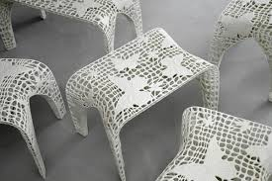University, started establishing businesses selling 3D printed interior products, from lamp fittings and fruit bowls, to furniture.

One of the most significant aspects of 3D printing is the ability to manufacture complex geometries. In fact, 3D printing is often used to make products that are impossible to produce using traditional processes such as plastic injection moulding. Designers are exploiting this geometric flexibility by enabling greater and greater levels of product differentiation.

Architects are now regularly producing very detailed models of buildings, interiors. 3D site plans and even whole master plans for redevelopments, made possible by linking 3 D printing with topological scanning and satellite data. It is even possible to extract data on a specific geographic area from Google Earth and 3D prints this as an aid to [master planning](http://landprint.com/). 3D printing architectural models provide the opportunity to reduce the number of steps, improving design time, while retaining fine details of the final architecture plan.

The Contour Crafting technology has the following unique features:  
-Reduces construction cost to about 30% of current cost.

-Speeds up the construction process by a factor of at least 50.

-Reduces construction injuries and fatalities (400,000 and 6,000 per year, respectively, in the US).

-Provides emergency shelter to the more than 37 million annual victims of war and natural disaster.

-Provides dignified housing to the low income population of the world.

-Contour Crafting eliminates construction wastes as the computer precisely adds material where it is needed.

-Dramatically reduces construction energy usage (by 90%) and CO2 emission (by 70%).

-Promises limitless architectural features such as curved walls.

[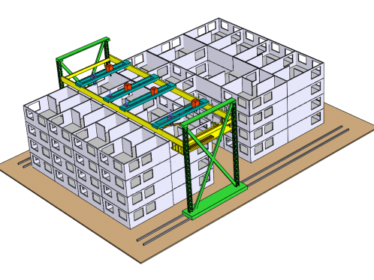](http://zbrella.com/wp-content/uploads/2015/06/CC3.bmp)In fact, Contour Crafting is completely customizable, meaning that, due to the design of the printer, unique shapes like curves and smooth edges would be possible. Traditional 3D printers typically print square edges with little variety, but Contour Crafting would allow commercial buildings to be fully customizable and therefore more versatile depending upon their use, which would lend to the ability to 3D print pipes, tunnels, and other rounded commercial structures.

 For example, towers, bridges, emergency shelters and even infrastructures such as water and sewage pipes could be printed in their entirety at a fraction of time and labor costs due to CC’s simplified, on-site, immediate printing process.

Contour Crafting also offers multiple ways to 3D print infrastructures, complete with different machines to get different jobs done. Each machine serves a different purpose and is capable of different functions, such as:

* **Single Detached Residential Building** -This can be done using the standard printing technology available.
* **Large & Commercial Building** - It is accomplished with a multi nozzle machine.
* **Tall Skyscraper** -Can be accomplished with a machine that has the ability to climb buildings.

 Because Contour Crafting is completely customizable, Dr. Khoshnevis believes the technology would be preferable to conventional methods of building and would drastically reduce the amount of time it would take to construct such infrastructures.